TaLK Prospectus Spring 2020

I. Program Description
The Teach and Learn in Korea (TaLK) Program invites young, adventurous college students and recent graduates to teach English to elementary school students living in the rural areas of South Korea. Funded by the Ministry of Education (MOE), the TaLK Program aims to cultivate a strong desire to learn English through the use of innovative and engaging classroom teaching methods designed by our own scholars. While teaching, participants will have the opportunity to learn about the many facets of Korean culture and find time to travel to distinct regions of the Korean peninsula. TaLK is the perfect program for those who aspire to lead the next generation and who seek to gain personal and professional enrichment through teaching.

II. Eligibility
- Nationality
- Citizens of Australia, Canada, Ireland, New Zealand, South Africa, the United Kingdom or the United States of America
- Overseas Koreans who are permanent residents in one of the aforementioned countries
- Korean citizens who have lived in one of the aforementioned countries as temporary residents for at least 8 years (with the intention of obtaining permanent residency), and who have completed both primary and secondary education in that country.

- Education
Bachelor's degree candidates who have successfully completed at least two (2) years of undergraduate education, or Associate's degree holders who completed their education at an accredited post-secondary institution in one of the aforementioned countries.
- Applicants completing the last semester of the second year are eligible to apply, but the final decision will not be made without the final official transcript indicating completion of two (2) years of undergraduate study.
- Applicants with an Associate's degree or completing their final semester are eligible to apply, but the final decision will not be made without the final official transcript with the date of degree conferment indicated.
- Recent graduates and graduate students
- Overseas Koreans in their 1st or 2nd year of undergraduate study are eligible if they qualify for the F-4 visa or hold Korean citizenship.
- Applicants with a degree not listed above must have their institution provide an official letter along with the official transcript to verify the following:
- Date of Degree Confer
- Duration of the Program (Must be at least 2 years)
- Higher Education Accreditation

- Qualifications
- Have a strong command of verbal and written English
- Meet the criteria of eligibility for one of the following visas:
E2-2 (Public Institution Foreign Language Instructor) or F-4 (Overseas Korean).
* Korean citizens do not need a visa.
- Be mentally and physically healthy and capable of performing assigned duties and responsibilities.
**Upon arrival in Korea, all TaLK scholars will undergo a mandatory medical checkup, inclusive of drug testing. If a scholar does not satisfy the health requirements, his/her scholarship will be rescinded.

III. Job Description & Responsibility
- General Information
TaLK scholars are required to participate in an online pre-orientation and on-site four (4)-week orientation program, and are prohibited from engaging in any activity (including other part-time jobs) not stated in their contract for the entire duration of the contract. Furthermore, the duties of the TaLK scholars are carried out under the guidance of the supervisor designated by the Provincial Office of Education (hereinafter “POE”).

- Job Description
- Teach English in the elementary school(s) designated by the POE during the term of scholarship.
- Prepare teaching materials and activities for English language education.
- Assist with activities related to English language education and other extracurricular activities organized by the school, the POE or the community.

IV. Scholarship Term and Place of Work
- Scholarship Term
The current offered scholarship terms are 12 and 6 months in length, with the possibility of future extensions.
- 12-Month Term: February 1, 2020 – January 31, 2020
- 6-Month Term: February 1, 2020 – July 31, 2020
Overseas Korean males who are dual/multiple citizens or permanent residents in one of the aforementioned countries should directly contact the Military Manpower Administration to determine their duration of stay in Korea.

- Teaching Hours
- Monday through Friday, an average of 15 teaching hours per week
(not inclusive of preparation and commute times)
- Class schedule is subject to change based on the school's needs.
- TaLK scholars may be assigned to more than one school.
- TaLK scholars are expected to show up at least an hour before class instructions to prepare for their lessons. Class preparation, time at school between lessons, and the commute to and from school are not considered overtime.

- Place of Work
- The POE will decide placements in accordance with the available quota. Refusal of placement will result in disqualification from the program.
- List of Participating Provincial/Metropolitan Offices of Education as of 2019-2020:
Gangwon-do | Chungcheongnam-do | Incheon City
Jeollabuk-do | Jeollanam-do

V. Benefits
- Monthly Stipend (*subject deductions such as taxes, school meals, etc.)
Payment of the monthly stipend - a fixed amount of 1,500,000 Korean Won (KRW) - will be provided starting at the end of the first month that scholars teach. The month of orientation will not be financially compensated, but instead, housing, training and meals will be covered by the TaLK Program.

- Settlement Allowance (one-time payment)
A fixed amount of KRW 300,000 is given generally within one month after arrival at the elementary school.

- Housing or Fixed Monthly Rent
The POE will decide the type of housing for each scholar. Monthly housing settlement (a fixed fee of KRW 400,000) may be provided instead, if a scholar wishes to make his or her own housing arrangement before his or her arrival in Korea. Any fees, charges, taxes and expenses incurred in using the apartment shall be borne by the scholar.

- Entrance Allowance & Exit Allowance
Entrance Allowance: Will be provided to the amount of 1,300,000 KRW once for all TaLK Scholars within the first 5 months of the contract term.
Exit Allowance: Will be provided an additional amount of 1,300,000 KRW once only to TaLK Scholars who have completed one consecutive year or longer with the TaLK Program. The exit allowance is not provided to those who complete the shorter 6-month term.

- Medical Insurance Coverage
All TaLK scholars are provided the Study Abroad Health Insurance Plan during the first six months of the TaLK scholarship period. Each POE reserves the right to choose the type of insurance plan for their TaLK scholars and the scholars must adhere to the decisions made by their POE.
100% reimbursement is not applicable under the Study Abroad Health Insurance Plan. Medical insurance coverage does not begin until the school registers their scholars for an Alien Registration Card (ARC).
Following the first six months, TaLK scholars will be automatically subscribed to the National Health Insurance Service, as mandated by Korean law (effective July 2019). Scholars will be responsible for 50% of the premium, while their POE will cover the remaining 50%.

Term Length | Per 6 Months
Vacation Days (Per Term) | 7 Business Days
- Vacation & Sick Leave
Vacation leave must be requested at least 15 days in advance and must be authorized by the Principal.

Under no circumstances should any TaLK scholar be absent without notifying the mentor teacher. A doctor's medical report (or a physician's note) must be submitted if sick leave is taken for three (3) or more calendar days. All class periods missed due to sick leave must be made up.

- TaLK Orientation
The online pre-orientation training, on-site orientation and online in-service training are designed to give TaLK scholars the foundation they need to make a successful start in their teaching career and life in Korea.
Each participant will have the opportunity to learn about life as a TaLK scholar and a chance to have his/her questions and concerns be answered during the on-site orientation period. They will also have the opportunity to meet with their POE supervisor, mentor teacher and Korean scholar(s).
- Online Pre-orientation: Must be completed before their entry into Korea.
- TaLK On-site Orientation: TBA (Early August and February, respectively)
- POE Orientation & School Placement: TBA (Late August and February, respectively)
All expenses including food, accommodation and participation in activities during the on-site orientation will be covered by the TaLK Program. If, for any reason, a scholar fails to complete the orientation, it will be considered as a breach of the scholarship term, thereby prohibiting them from further participation in the program.

- Co-Teaching System
POE-designated co-scholars (Korean university students) may be present to teach cooperatively with the Overseas TaLK Scholar. This is highly subject to availability.

- Government Scholarship Certificate
A certificate of Korean Government Scholarship will be awarded at the end of the scholarship term to those who have successfully completed their term in the TaLK Program.

- Cultural Experience Programs
Programs for experiencing the Korean culture may be arranged by each respective POE. Cultural experiences may be held on the weekends or weekdays under the POE's discretion.

VI. Application Instructions and Information
- Online TaLK Application
All program applicants are required to complete an online application (Parts A&B) by creating a TaLK (My Page) account on the TaLK Web site at http://www.talk.go.kr. A registered, valid e-mail address and password are required to access the online application form.
Following the form submission, applicants can view or check the status of their application by logging in to MY PAGE.
Once the application office starts the initial screening process, changes to the application cannot be made.
In case of any technical difficulty while completing the online application, the forms can be downloaded, completed and sent via e-mail to talkkorea@korea.kr.

- Application Offices
- Korea: Head Office in Bundang, Seongnam (marked as Seoul)
**Applicants residing in Ireland or South Africa must apply directly to the Head Office in Bundang.
- Australia: Korean Embassy/Consulate in Sydney
- Canada: Korean Embassy/Consulate in Toronto, Montreal, Ottawa and Vancouver
- New Zealand: Korean Embassy/Consulate in Auckland
- UK: Korean Embassy/Consulate in London
- USA: Korean Embassy/Consulate in DC, Atlanta, Boston, Chicago, Houston, LA, New York, San Francisco and Seattle
- Checklist of Items Required for a Complete Application
**The following application documents and support materials must be received by the application offices by the set deadline. NOTE: INCOMPLETE APPLICATIONS WILL DELAY PROCESSING AND/OR LOSE PRIORITY.

- Application Part A: Applicant Profile & Photo
- Information on Emergency Contact, Education and Work Experience must be fully provided.
- A hand-written signature is required at the bottom of the application.
- A passport type, head shot picture with a solid background is required for international safety and identification purposes.
- Applicants residing in Ireland or South Africa or in Korea at the time of application must select "Seoul " as their "Location of the Application Office."

- Application Part B: Personal Essay & Self Medical Assessment
  - The type-written essay should be a minimum length of 700 words and a maximum length of 1,000 words.
  - A hand-written signature is required at the bottom of the medical self-assessment.
  - A doctor's note is required only for any medical condition that requires special attention. A doctor's note form is available at www.talk.go.kr under the "Required Documents" section.

- Application Support Materials
A Lesson Plan **This document will give the application evaluators an idea of the applicant's awareness of their future role as instructors.
- Estimated duration: 40 minutes
- Creativity, research, and a thorough understanding of lesson activities must be displayed.
- Key Expressions: Useful conversational phrases that students will have command over by the end of the lesson.
- Development: Thorough, step-by-step description of three (3) core activities that incorporate key expressions.
- In addition to the subject that you will be teaching (the "what"), elaborate on the steps you need to take (the "how") to ensure your students have fully understood and can freely use the key expressions.
- Provide worksheets if you intend to use them (either include them in the lesson plan on a new page, or attach them as separate documents).
- Two Recommendation Letters (Signed and Sealed)
- Preferably from a professor, or current/former employer
- Invalid if e-mailed, faxed, photocopied, or opened
- Invalid if recommendations are made by family members or friends
- Invalid if recommended by high school teachers unless the applicant is in his/her first semester in college.
- If hand-carried to the application office, a stamp or signature must be on the back flap of the envelope.
- For returning scholars, one of the letters must be written by their former mentor teacher.
- An Official School Transcript (Stamped and Sealed)
- The transcript must bear the college seal, date, and appropriate signature.
- If hand-carried to the application office, the school seal, stamp, or signature must be on the back flap of the envelope.
- [Note] Korean citizens who are not a permanent resident in one of the aforementioned countries must also submit a Verification Letter of Education (or Transcript) from their primary and secondary schools from their country of current residence. In the Verification Letter of Education, the duration of attendance at the school must be indicated as well as the signature of the appropriate school administrator.
- An Apostilled, Nationwide Criminal Record Check *Mandated by the Ministry of Justice of Korea
- U.S. applicants must submit an FBI fingerprint CRC
- Under the International Apostille Agreement, applicants can obtain the Apostille stamp from designated authorities: http://www.apostilleinfo.com
    - **An Apostilled, state-level criminal record check applies only to U.S. applicants who have been residing in the same state since the beginning of high school.
    - **Canadian applicants must get their CRCs notarized at their nearest Korean Embassy/Consulate.
- CRC must be issued within six (6) months from the application submission date.
**The TaLK Office will not provide the Entrance and Exit allowances to those who do not submit this document. Failure to submit this document may also result in a deportation order.
- A Copy of the Passport Photo Page
- A copy of Permanent Residency Certificate (for Korean Nationals)

- Application Process & Timeline
→ For the Spring 2020 Intake: Applications have been opened since March 2019, and processing will begin in September 2019.
* Local application offices will open at a date later than the above mentioned.
** For both intake periods, the deadline will be determined once required numbers are established through internal processes at a later date.
Applicants may check the status of their application at anytime by logging into MY PAGE.
Make sure to read Acceptance Notice on “MY PAGE” for visa information.
If the offer is declined or unclaimed for seven (7) days from the time the acceptance package is sent, the offer will be rescinded and given to the first available applicant on the waitlist.
In case of declining the scholarship, make sure to indicate the decision by clicking "No" and send us a refusal letter stating the reason(s) via e-mail at talkkorea@korea.kr.
Forfeiting after accepting the TaLK scholarship will affect the applicant's acceptance into the TaLK Program in the future.
Details of location and elementary school will be listed on your "My Page" under "Placement" after mid-July.
**The TaLK Office reserves the right to rescind the acceptance offer at any time in the case that the applicant altered, falsified or omitted information during the application process; lacks the capability to successfully perform the scope of work; and/or has engaged in behavior that displays a lack of judgment or integrity.

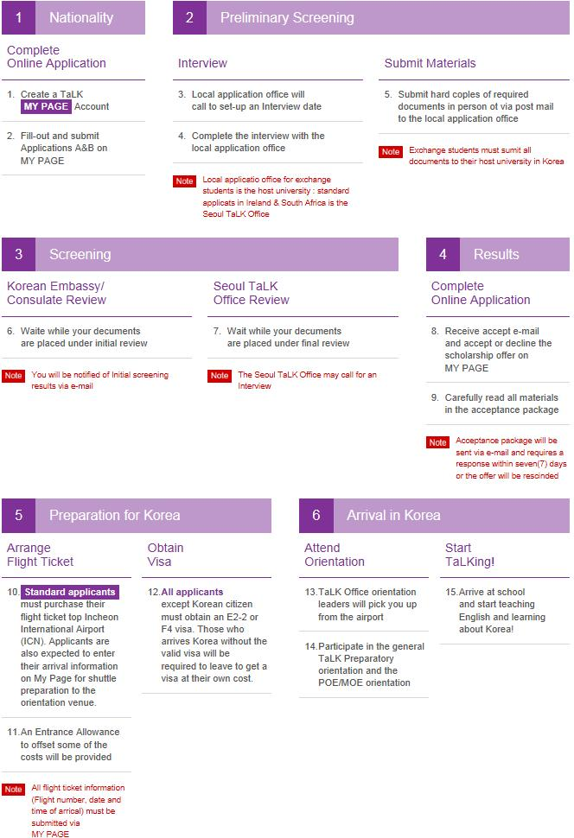

- Disclaimers & Reminders
- Those of Korean Heritage in their 1st or 2nd year of undergraduate study must check their F-4 visa eligibility before applying.
- Only those candidates who pass the preliminary/initial screening conducted by the Korean Embassy/Consulate will undergo the final review by the TaLK Selection Committee.
- TaLK does not disclose any information to individual applicants regarding their application status.
- TaLK does not grant acceptance deferments.
- All application materials are non-returnable, regardless of the final decision or reason for request.
- Joint application does not guarantee acceptance of both individuals into the TaLK Program nor the same placement. Each individual is evaluated and processed based on their own merits, and separately from one another.
- Placements for successful candidates are done at the sole discretion of the TaLK Office and POE.
- All e-mail correspondences and inquiry calls are kept on record and considered part of the evaluation process.
- New applicants have priority consideration over returning scholars.
- Returning scholars must submit new application documents, including an apostilled copy of their Bachelor’s degree, and undergo the entire application process.
- Forfeiting after accepting the TaLK scholarship offer will affect the applicant's acceptance into the TaLK Program in the future.

Contact Information
Teach and Learn in Korea (TaLK) Program
National Institute for International Education
191 Jeongjail-ro, Bundang-gu, Seongnam-si, Gyeonggi-do
Republic of Korea [13557]
Tel (within Korea): 02-3668-1399
Tel (International): +82-2-3668-1399
Fax (within Korea): 02-764-1328
Fax (International): +82-2-764-1328
E-mail: talkkorea@korea.kr

